**Skelet 3D – Editor’s Manual**

This is a thorough guide to Skelet 3D’s editorial functions. If you decide not to read anything else, please read this: **SAVE YOUR CHANGES OFTEN**, otherwise you risk losing your progress.

Table of Contents

1. Just a Visitor – Unregistered User 3

1.1. Browsing Categories and Pages 3

1.2. Viewing Models 3

1.3. Language Selection 4

1.4. What They Cannot Do (But You Can) 4

2. Login and Security 5

2.1. Login 5

2.2. Logout (Sometimes Unwanted) 5

2.3. Security 5

3. Managing Models 6

3.1. Entering the Model Manager 6

3.2. Uploading New Models 6

3.3. Managing Existing Models 6

4. Managing Images 7

4.1. Entering the Image Manager 7

4.2. Uploading New Images 7

4.3. Managing Existing Images 7

5. Managing Pages 7

5.1. Creating New Pages 8

5.2. Editing Pages 8

5.2.1. Changing the Name 8

5.2.2. Working with Components 8

5.2.3. Text Component 9

5.2.4. Headline Component 9

5.2.5. Image Component 9

5.2.6. 3D Model Component 9

5.2.7. Publishing the Page 9

5.3. Deleting Pages 10

6. Editing Labels 10

6.1. Adding New Labels 10

6.2. Editing Existing Labels 11

6.3. Deleting Labels 11

7. Things You Cannot Do 11

# Just a Visitor – Unregistered User

Before starting the editing process, it is important to know the basic behavior of the website and its public features.

## Browsing Categories and Pages

Browsing typically starts by selecting one of the categories on the main page. Then you can browse its subcategories and pages and continue selecting subcategories until you reach your desired page.

To return to a parent category, you can either use your browser's Back button or select an item in the path to current category (or page).

Clicking the logo always returns you to the main page.

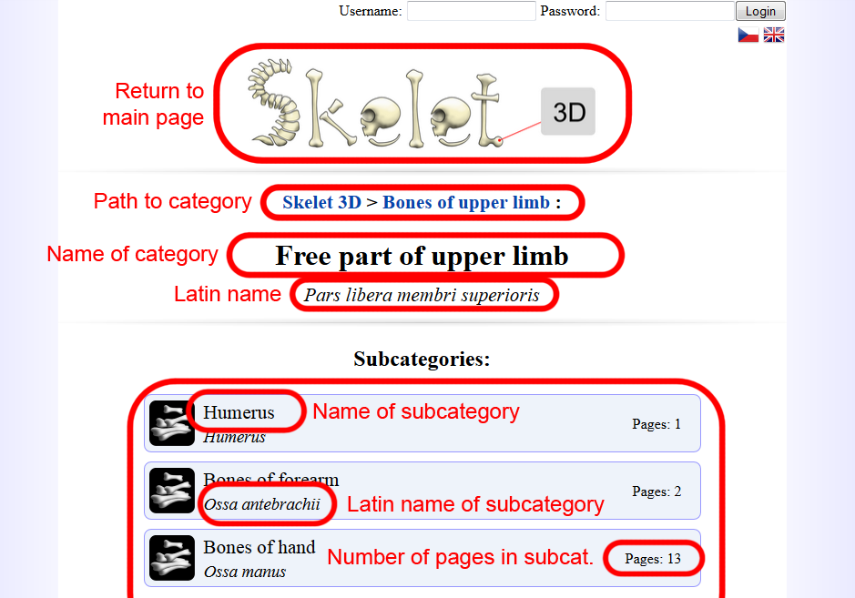

1: Navigation user interface and its features

## Viewing Models

Note: To view (or edit) the 3D models you're going to need a browser supporting WebGL.

If a page contains a 3D model and your browser supports WebGL, the 3D scene will become an interactive component of the page.

If you're seeing a "LOADING" sign in place of the model, the model is still downloading. Some models are rather large and might take a while to download.

There are several ways to manipulate the scene:

* Rotate the view by dragging the left mouse button
* Pan the view by dragging the right mouse button
* Zoom with the mouse wheel

The models include “labels”, important points marked by a red dot and a name tag.

Each label can be selected by clicking its tag or red marking point. That opens a detailed description if available. You can unselect the label by clicking it again, or you can simply select another label by clicking that instead.

You can select one of several labels’ display modes in the top right corner of the scene. Currently the 3D viewer supports these modes:

* Labels – Shows all labels including their titles.
* Pins – Shows all labels’ locations, but no titles until they’re selected.
* Blank – Labels are not shown at all.

## Language Selection

You can easily change the site's language by clicking the small flags in top right corner.

Not all pages are necessarily available in all language variants to unregistered users. Editors, on the other hand, can access even blank and unpublished pages.

## What They Cannot Do (But You Can)

Unregistered users are not allowed to (and not able to) upload, add, change or delete anything that affects the content of the website.

They also cannot access unpublished pages, such as your “work in progress”, until you mark the page as published.

They can sometimes access editor-only pages such as Model Manager or Page Editor, for example if you give them a link to such a page, they find it in the history or just randomly guess it. However, nothing too bad can happen as the server does a login check every time changes are to be saved. Even if users get to editor-only pages, they cannot save the changes.

# Login and Security

## Login

To prevent unauthorized users from editing the content, editors are required to log in. You can log in simply by entering your username and password in the top right corner of the website.

Once you’re logged in, the top right corner will display your name instead of the username and password fields.

If you forget your password or simply don’t have an account yet, contact the website’s administrator.

## Logout (Sometimes Unwanted)

You can easily log out by hitting the “Logout” button in the top right corner.

Please note that if you stay logged in for an extended period of time (such as overnight), you might be logged off automatically. This might also occur randomly if changes are made on the server. You might not notice this until you try to save changes, at which point you might lose the progress. **SAVE OFTEN.** You can easily find out if you were logged off automatically by refreshing the page before you start you work.

## Security

From a security point of view, Skelet 3D is a low-risk website. No sensitive or strictly confidential data should be present (you should treat everything you enter into the system as possibly public). Because of that, attackers have little reason to attempt to break into the website.

The only reason would be vandalism, which could happen if someone gained access to your password. Please try to prevent this by keeping your passwords to yourself.

Most content should be backed up in regular intervals by the IT department responsible for the server. Please contact an administrator immediately in case of vandalism, so the data can be restored and passwords changed.

# Managing Models

3D models are the trademark of this website. It is your task to upload them, put them in a page and add labels to them. Before you can use or edit 3D models, you need to upload them into the database, which is the topic of this section. Adding models to pages and editing labels is covered in other sections.

## Entering the Model Manager

If you’re logged in as an editor, several additional menu items should appear right under the main logo. One of them is the Model Manager; you can simply click the button.

## Uploading New Models

You can easily upload new models in the Model Manager. In the “New Model” section, hit the “Browse…” button and select a 3D model file from your computer. It is suggested to upload models smaller than 2MB. This is not a strict limit, but please remember that users have to download the file every time they want to view the model and large files take longer to download.

*The application currently* ***only supports STL models****. Binary STL models are preferred because of their smaller file size. The application automatically places the models in center and unifies their size, so no calibration is required. Initial rotation of the model is preserved (but should be unimportant).*

Before uploading, enter a name in the “Name” field. This name should describe the model so that you (and other editors) can identify the model in a list of all models. The name can be changed later.

Finally, hit the “Upload” button and wait for the file to be uploaded. This might take several minutes depending on the file size and connection speed.

## Managing Existing Models

The Model Manager contains a list of all uploaded models.

You can change the name of a model by simply overwriting its current name and then clicking the “Change Name” button.

You can delete a model permanently by clicking the “Delete” button. Note that you cannot delete models that are used in a page. Remove them from the page first.

# Managing Images

Images are an important part of a website’s content. Before you can insert images into a page in Skelet 3D, you need to upload them into the database first.

## Entering the Image Manager

If you’re logged in as an editor, several additional menu items should appear right under the main logo. One of them is the Image Manager; you can simply click the button.

## Uploading New Images

You can easily upload new images in the Image Manager. In the “New Image” section, hit the “Browse…” button and select an image file from your computer. Most common image formats are supported. Good choices for online use include .jpeg, .png or .gif.

Before uploading, enter a name in the “Name” field. This name should describe the image so that you (and other editors) can identify the image in a list of all images. The name can be changed later.

Finally, hit the “Upload” button and wait for the file to be uploaded. This might take several minutes depending on the file size and connection speed.

## Managing Existing Images

The Image Manager contains a list of all uploaded images.

You can change the name of an image by simply overwriting its current name and then clicking the “Change Name” button.

You can delete an image permanently by clicking the “Delete” button. Note that you cannot delete images that are used in a page. Remove them from the page first.

# Managing Pages

Pages are what the Internet is all about. So is Skelet 3D. You need to create pages if you want users to see the models, images and text.

Pages in Skelet 3D always belong to a category and you can see their icons when you open their parent category.

Pages that are blue are published pages that anyone can see. Red pages are not published and only editors can work with them.

## Creating New Pages

If you’re logged as an editor, extra buttons will appear inside each category. You can use the large “Add New Page” button right under the list of subcategories.

This button will create a new blank page in current category. The page will be called “NEW PAGE”, will be unpublished (red) and will have no content. It will be created in all language variants.

## Editing Pages

To edit a page, go to its parent category, find the page and the “Edit” button on the right side of the item. This will take you to the Page Editor.

To save changes you made in the page, simply click the “Save Changes” button in the left-side toolbar.

You can only edit one language variant at a time. All the content in a page (except for Latin name) will be specific for each language. To edit other language variants, please switch website language (see 1.3).

Please note that leaving the Page Editor, pressing the Back button, switching language or even reloading the page will discard all unsaved changes. **SAVE CHANGES OFTEN** to prevent frustration.

### Changing the Name

To change the name of the page, simply overwrite the “Page name” field in the left-side toolbar. To change the Latin name, overwrite the “Latin name” field.

While Page name only applies to current language variant, Latin name is shared by all language variants. It means that changing the Latin name in one language in fact changes the Latin name in all languages.

### Working with Components

The Page Editor lets you edit pages by working with simple pre-made components. Headlines, paragraphs of text, images and 3D models are examples of such components.

You can add a new component of a given type by clicking the buttons under “Add component” in the left-side toolbar.

On the right side of the Editor, you can see a list of components currently in the page. Every component is slightly different, but they have 3 buttons in common. These are located in the top right corner of each component:

* Arrow pointing up moves this component one position up, swapping it with the component directly above it.
* Arrow pointing down moves this component one position down, swapping it with the component directly below it.
* “Delete” button removes this component from the page.

### Text Component

A text component is simply a paragraph of text to be displayed in the page.

Add it to the page and then write into the main text field of the component (replacing the “…” placeholder).

### Headline Component

A headline component is a section headline. It is a smaller headline than the name of the page and you can use as many as you need in a page.

Add it to the page and then write into the text line of the component (replacing the “…” placeholder).

*Do not use this component to write the name of the whole page. Page name is added automatically.*

### Image Component

An image component is an image with a description under it.

Add it to the page, select an image from uploaded images (see section 4) and write a description.

The image will be the same size as the uploaded image and placed in the center. If it is too wide to fit, it will be automatically downscaled to fit into the page (95% of the page’s main column).

The description will be aligned to center, placed right under the image and set in a smaller bold type.

### 3D Model Component

A 3D model component is a 3D scene displaying a labeled model. It can have a description under it.

Add it to the page, select a model from uploaded models (see section 3) and write a description.

The 3D scene will fill the width of the page.

The description will be aligned to center, placed right under the image and set in a smaller bold type.

### Publishing the Page

Next to the “Save Changes” button is a “Published” checkbox.

Published pages can be seen by all users, so don’t forget to publish the page when you’re done.

Unpublished pages can only be seen by editors. It is a good way to ensure that pages are ready and representative before releasing them to the public.

Note that publishing affects current language variant only, so you can have pages published in English but unpublished in Czech (or vice versa).

## Deleting Pages

To delete a page, go to its parent category, find the page and the “Delete” button on the right side of the item. This action will **PERMANENTLY DELETE ALL LANGUAGE VARIANTS OF THE PAGE**, so please use this with care.

# Editing Labels

3D models are a great feature and labeling the important parts makes it even greater.

To edit labels of a model, it is enough to visit (just visit, not edit) a page with a 3D model component. If you’re logged as editor, the 3D scene will include a label editor as well. It doesn’t matter whether the page is published.

You can save changes by clicking the “Save Changes” button in the bottom right corner of the 3D scene.

Labels are shared among language variants, but their text is not. This means that when you add a label in one language, the same label in that place will be inserted for all languages. However, you then need to edit the text in all other languages. To edit other language variants, please switch website language (see 1.3).

Please note that leaving the page, pressing the Back button, switching language or even reloading the page will discard all unsaved changes.

## Adding New Labels

You can easily add a new label by clicking the “New Label” button in the bottom left corner of the 3D scene, then pointing your cursor at a point on the bone and clicking again. This will automatically select the new label, expanding its box (located at the bottom of the 3D scene)

Replace the “< Label >” text in the top line of the box by a title (which can be displayed in 3D). Also replace the text in the large text field with a more detailed description. The description can be longer than the box; a scrollbar will appear if necessary.

## Editing Existing Labels

Select a label by clicking its tag or red marking point. You can then edit selected label.

*To unselect, you need to click the red marking point, because clicking the tag is used for dragging it around.*

There are several editable properties of a label:

* Title – Replace the top line of text in label’s expanded box
* Description – Replace the text in the large text field in label’s expanded box
* Nametag location – Click and drag the tag of the selected label to find a better spot for it

## Deleting Labels

Select a label by clicking its tag or red marking point. You can then delete selected label by clicking the “Delete” button at the bottom of the box. Note that this deletes the label in all language variants.

# Things You Cannot Do

Some features are not available yet. Other features are just not meant for editors. Here is a list of things you unfortunately cannot do without the help of an administrator:

* Create new types of components
* Customize pages outside of the “component” framework
* Edit categories
* Edit the main page
* Register new users
* Add new languages

If you want one of these tasks done (or something similar), you need to contact an administrator.